Website I am writing for: [Business Insider](https://www.businessinsider.com/)

Audience Demographics: Results and action-oriented individuals interested or working in business, particularly customer-related segments such as marketing, sales, or customer service and experience.

---------------------------------------------------------------------------------------------------------------------

**If you want better customer trust and loyalty, it’s time to get personal**

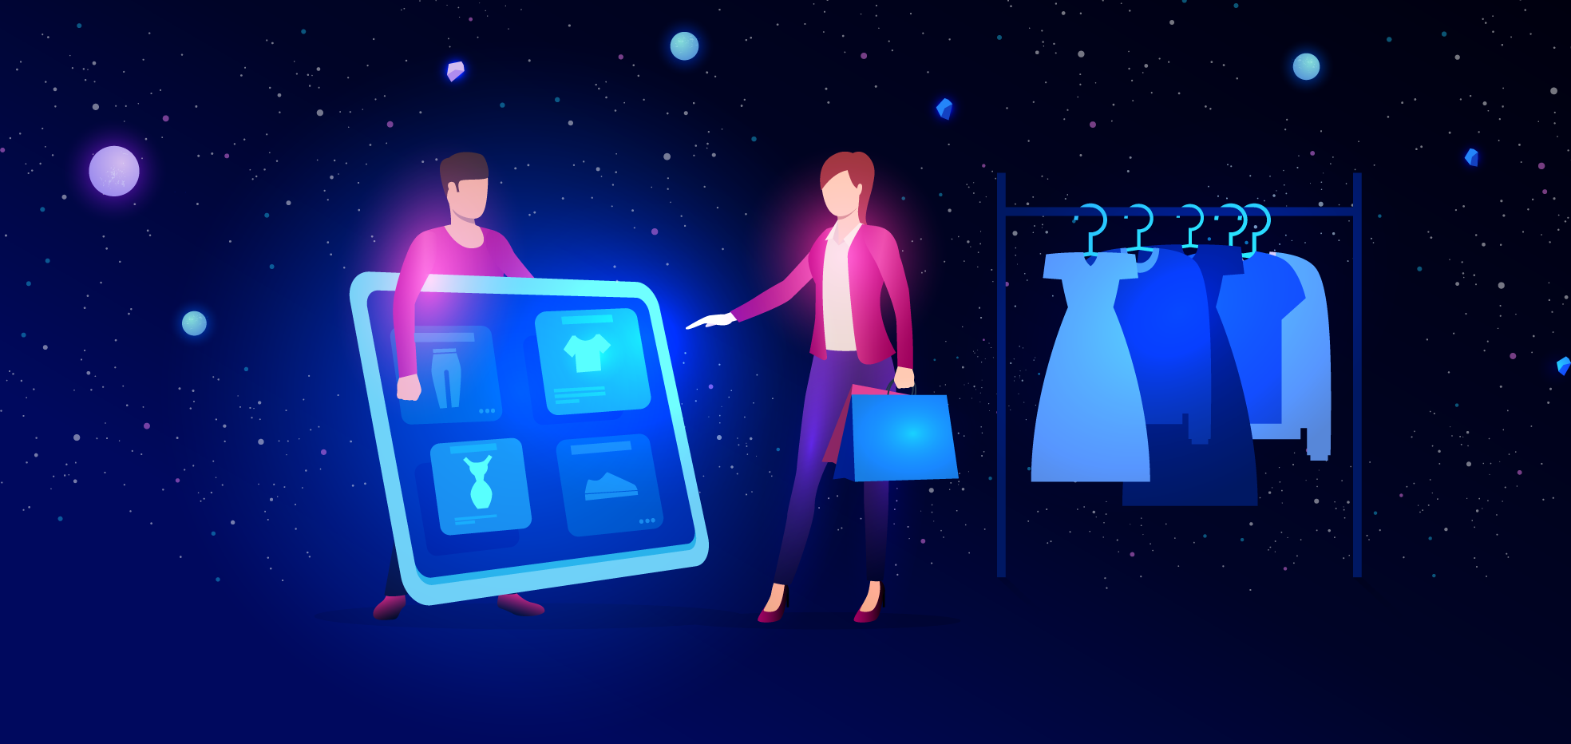

A [study](https://www.sciencedirect.com/science/article/pii/S0969698919314882) by the *Journal of Retailing and Consumer Services* summarizes the positive effect omnichannel personalization can have on emotional customer experience and loyalty. The results reveal increased customer appreciation for personalized offers, newsletters, and advertisements and that these personalization tactics increase customers’ intentions to purchase again.

Prior studies have primarily shown the impact of personalized communications in specific areas, such as mobile or online channels. However, this new study takes a look through the lens of how personalized omnichannel strategies can enhance customer experiences in particular.

The world of business has been rapidly changing with new digital technologies, allowing for enhanced consumer shopping experiences and new channels for companies to communicate with their customers. For example, social media and company pages allow consumers to interact and engage in direct communication with companies.

Because of this, businesses are evolving their efforts towards omnichannel communication, defined by [Mitel](https://www.mitel.com/features-benefits/omnichannel) as, “using different channels, or methods of connecting with customers and integrating them so the customer experience is seamless, regardless of the channel they use.”

Going a step further, omnichannel personalization has been marked by consulting companies, such as [McKinsey](https://www.mckinsey.com/business-functions/marketing-and-sales/our-insights/the-end-of-shoppings-boundaries-omnichannel-personalization), as the next big marketing opportunity. [Personalization](https://doi.org/10.1016/j.jretconser.2020.102233) involves providing customized content and services based on customer data while adapting to fit customers’ needs. In other words, personalization aims to present suitable products or services to customers at the optimal time, place, and context.

James Brown, CEO of Smart Communications, a technology company that helps businesses engage in more meaningful customer communications, [claims,](https://finance.yahoo.com/news/smart-communications-study-reveals-increasing-120000383.html?guccounter=1&guce_referrer=aHR0cHM6Ly93d3cuZ29vZ2xlLmNvbS8&guce_referrer_sig=AQAAABPr6S_JZr2R3lJg3Duk_cQ0Q3FfRKXlawV-pxTXCAR-4vsuvnLh_a6mYmdcQYIVAWc_Dv8ortGpRhFaLas1574O8GTSKzlktLjuUFFtM5pIJ7_JglQjLRypW8B1z1CV_6vslUQMUU7jiwREXlPny2nuHQ-wIKWcJHIHwsMcFOB-) “Companies must evolve their strategies to exceed customer expectations through two-way, digital-first conversations that honor preferences and provide an exceptional end-to-end experience. Not only will this lead to an enhanced customer journey, but it will also have a positive impact on the company’s bottom line.”

Many successful companies have already integrated omnichannel personalization efforts. For example, the [Starbucks rewards app](https://www.starbucks.com/rewards/mobile-apps/) provides an experience beyond the traditional customer loyalty program. The application allows users to pay, order, access promotions, send gifts, and see personalized recommendations in a gamified fashion. It provides a seamless personalized omnichannel experience by seamlessly integrating the app with mobile and in-store experiences.

However, implementation is not without challenges: According to [NAPCO Research](https://www.ritterscommunications.com/assets/pdfs/Napco_Direct_Mail_white_paper.pdf), the top barriers for companies implementing personalization efforts includes budget limitations, difficulty maintaining databases, and cost. Yet, keeping in mind these challenges, studies point companies to integrate omnichannel personalization methods as a competitive advantage.

These conclusions provide both theoretical and managerial insights towards improved customer relationship management for businesses. For businesses, the results indicate the positive outcome from investing in and developing a company’s presence in diverse omnichannel initiatives. Furthermore, businesses should create more personalized offerings and advertisements to improve the holistic customer experience.

Global CMO and Senior Vice President of McDonald’s, Alistair Macrow, [says](https://deloitte.wsj.com/articles/amazon-mcdonalds-tie-personalization-to-purpose-01626462130) on personalization, “More than ever, it’s important for brands to stay close to customers. By developing a solid foundation in customers’ changing needs and lived experiences, brands will be better prepared to react to future challenges in a way that puts those individuals first.”